Choosing the right deployment

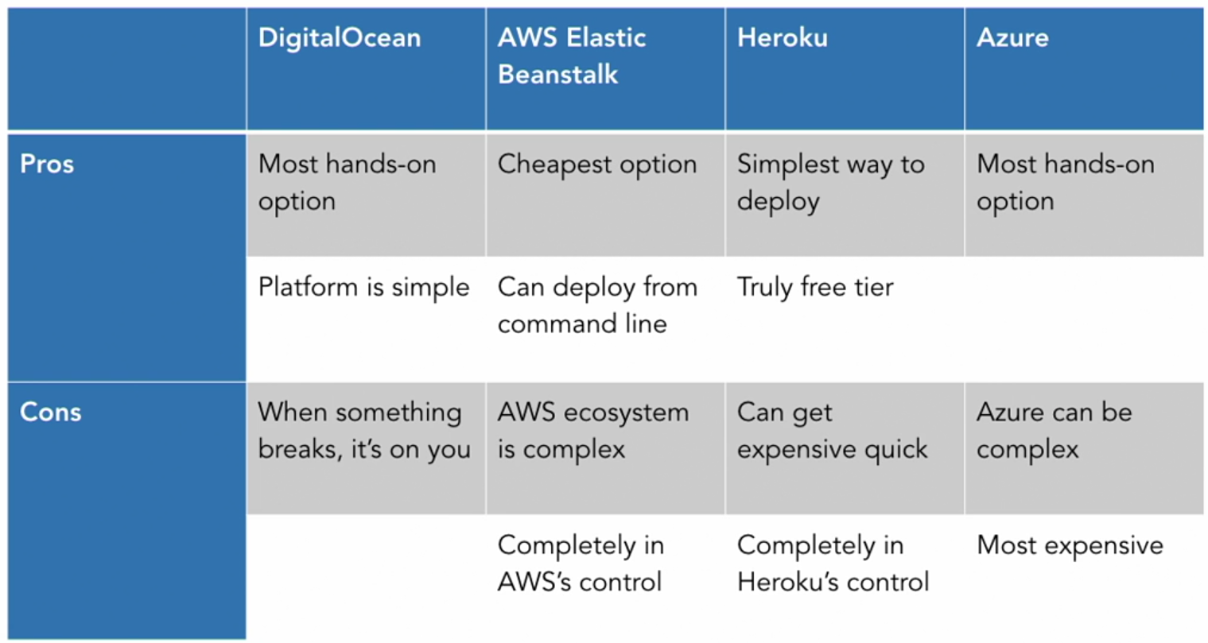

Digital Ocean

* First step is registration and email conformation.
* Payment information is required.
* The after that just click on trying out digital ocean and skip through the survey that looks like a selection menu for services.
* Now we need to create a digital ocean droplet (It is same thing as a server).
* In the left most there is a list of projects that are basically collection of droplets (Server).
* In the top right click create and then select droplets.
* Then it will ask what kind of server or droplet you want to create.
* In this the selection is ubuntu linux server and then specify the version of ubuntu which is required.
* The selected one was 18.4.
* Then select the droplet size. Billing information is in accordance to the size. (Cheapest one is $5/month)
* Then there is a selection that ask if we want backup. That is one dollar a month.
* Then the next to select in the scroll down is the region where we want our server.
* Then the host name creation, this is essentially the name for our server.
* So, in accordance to the tutorial it is portfolio-ubuntu.
* Then an email is sent by digital ocean that has the login credentials for the server that was just created.
* Key information is the ip address and user credentials.
* Then move to the terminal and write ssh root@ip (ip is the ip address).
* The root is the user and then it will ask for password that is also mentioned in the email.
* Then its required to set the password for the first-time login.
* Then create a user as it is not a wise choice to use an root user ever time in linux.
* So, for that adduser and then the name of the user name.
* Then set the password for that user.
* Then it will ask for some other information that can be skiped.
* Then to give the user root privileges.
  + Usermod -aG sudo username
* Then check the new user is working.
  + Ssh username@ip
  + Then type in the password for that user.
* Check the resource out at the link:
  + <https://www.digitalocean.com/community/tutorials/how-to-set-up-django-with-postgres-nginx-and-gunicorn-on-ubuntu-18-04>
* Update server:
  + Sudo apt-get update
  + Sudo apt-get upgrade